In recent times, the medical field has been subjected to various challenges due to various reasons. The fast-paced environment of today and due to various disorganized eating habits have led to various obstacles in the field of medicine. Depressive disorders, high blood pressure, cancer, diabetes, and a variety of transmissible illnesses are just a few of the usual side effects of a fast-paced, stressful lifestyle. The goal of prompt identification has been to halt and manage these medical problems as soon as possible. This has recently become an issue. However, considerable scientific progress with enhanced diagnostic potential has additionally been a huge step forward in periods like these. Disease identification at an early stage and Enhanced imaging of the interior structure of the body, as well as convenience of diagnostic processes, have been achieved even before symptoms appear, thanks to an emerging field of medical laboratory science known as nanodiagnostics. Current approaches being developed for application in nanodiagnostics include the use of microchips, biosensors, nanorobots, nano identification of single-celled structures, and microelectromechanical systems. This article provides a broad overview of current nanotechnological breakthroughs in medical diagnosis and forecasts prospective opportunities and potential for improved healthcare delivery.

**Introduction**

Although the manufacture and utilization of tiny particles unseen to the human eye are not new discoveries, the idea of nanotechnology has recently been at the forefront of scientific inquiry. Colloidal silver and gold nanoparticles found in the antique Roman glass cup were discovered to be liable for the phenomena that cause it to reflect varied hues when light. The elasticity and resistance observed in the mythical Damascene Sword have been attributed to nanometer-sized carbon particles detected in them. From the physical to the environmental and even the life sciences, the use of nanoparticles to obtain results, monitor processes, and participate in responses has been not only exploratory but also fascinating. Nanotechnology is becoming increasingly important in the life sciences, notably since components of functional biological units such as deoxyribonucleic acid (DNA), ribosomes, and ribonucleic acids in live cells, for example, are primarily of nanoscale size. This opens up the possibility of using nanotechnology to impact various cell components, such as screening, detecting defects, improving, incorporating, or knocking them off. Nanotechnology, according to the United State Environmental Protection Agency involves creating and using structures, devices, and systems that have novel properties and functions as a result of their small and/ or intermediate size; it is the branch of science that employs the use of nanoscale particles, studying its peculiar characteristics and employing these to obtain desired outcomes in the fields of Engineering, Medicine, Agriculture, or Pharmaceuticals. Nanotechnology is concerned with nanoparticles. A nanoparticle is defined as any substance having dimensions less than 1 m. Many valuable instruments have been developed by nanotechnology for the identification of biomolecules and analytes relevant to diagnostics. nanodiagnostics. A thorough grasp of nanoparticles and their distinctive characteristics provides insight into the odd reasons for their use in various sectors, particularly medical diagnosis. In numerous medical textbooks, medical diagnostics has been explained using various snappy terms. However, to capture the main concept, the homepage of the Journal of medical diagnostic methods website, with slight alterations, defines it as the discipline or practice of the diagnosis, which includes identifying and describing a disease state and its responsible factors, using signs and symptoms obtained from patient history or physical examination of patients or samples with the help of several diagnostic techniques. The goal is to determine which illness is being treated, managed, or endured. This is especially important because any attempt to cure or manage a medical condition must first diagnose the sickness. Thus, medical diagnosis has a long history, beginning with the primitive approach of organoleptic assessment of body samples and progressing to the era of microscopy and now to the use of biosensors and body imaging. As a result, the incorporation of nanotechnology into better diagnostics is not only beneficial but also a welcome move. Nanodiagnostics is a new term that describes the use of nanotechnology methodologies and techniques, as well as its concepts, for diagnostic reasons. It covers but is not limited to, the manipulation and evaluation of single molecules, as well as the scaling down of systems and platforms to make use of nanoscale features obtained from interactions between surfaces and biomolecules. Nanodiagnostics is an evolving application of nanoscale technology to meet the demand of clinical diagnostics, determining disease state, any predisposition to such, the pathology of the condition, and the identification of causative organisms. With nanotechnology, diagnosis is being carried out on a nano-scale leading to a trend of the use of handheld devices that are easy to use and marketable. Nanodiagnostics as surging new field of molecular diagnostics, has been positively changing laboratory procedures, providing new ways for patient sample assessment and early detection of disease biomarkers with increased sensitivity and specificity. Nanoparticle platforms have been developed and optimized for the detection of pathogens and cancer biomarkers such that diagnostic procedures now become less cumbersome but more sensitive because most of the complex procedures are now integrated into a simple device having the capacity to be used for on-the-spot diagnosis.

**Nanoparticle (Nanomaterials) Classification**

**1.1.1. Nano Tube**

These are cylindrical carbon molecules with novel properties that make them potentially useful in many applications in nanotechnology, electronics, and the material sciences. They exhibit extraordinary strength and unique electrical properties and are good conductors of thermal energy; this is because the chemical bonding is in line with sp2 orbital hybridization. Examples include fullerene, an allotrope of carbon. A research team at the University of Connecticut has reportedly used a sensor made from densely packed carbon nanotubes coated with gold nanoparticles, to develop a device capable of detecting oral cancer from samples. Carbon nanotubes and Silicon nanowires have been utilized for the detection of various volatile organic compounds present in breath samples of lung and gastric cancer patients respectively

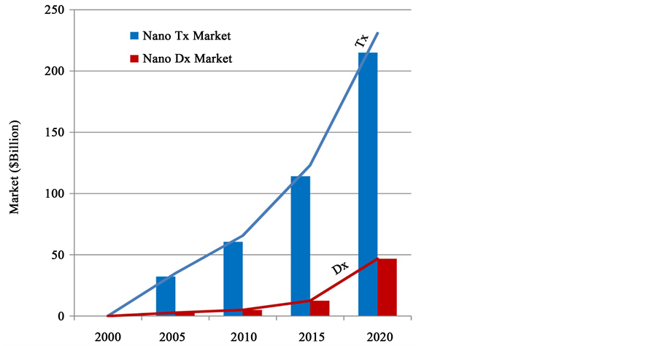

**Figure 1**. Graphical representation of historical and projected records of nanodiagnostic (Dx) and nanotherapeutics (Tx). Source: (Baseline data and compounded annual growth rates are based on BCC Research 2010.

**1.1.2. Nano Crystal**

They are crystalline materials with at least one dimension being less than 1µm and their properties, both electrical and thermodynamic, are size dependent. An example of these crystals is that of Elan pharma International Limited based in Ireland involved in nanoparticle drug formulation. Nanocrystals are good semi-conductor in the 10 nm and show a loose microstructure, with nanopores situated between the crystals. The surfaces of the pores are modified such that they could adsorb protein, due to the addition of silica molecules. Bone defects can be treated by using these hydroxyapatite nanoparticles. An international co-funding arrangement in nano drug development will equally be a good step in expanding treatment.

**1.1.3. Nanobots**

Also known as nanorobotics, are robots of nanometer (10−9 m) scale, that has been applied in medicine for early diagnosis as well as targeted drug-delivery for treatment of cancer, pharmacokinetic monitoring of diabetes and healthcare. Nanobots dentrifices (dentifrobots), for instance, when used as mouthwash or toothpaste can cover all subgingival surfaces, thereby metabolizing any trapped organic matter into harmless and odourless vapors. Pathogenic bacteria that exist in dental plaque are identified and destroyed, using properly configured dentifrobots. In fact, nanobots have been predicted to be injected into patients so as to perform work at the cellular level. Biochips and nubots are good examples of nanobots.

**1.1.4. Nanowires**

Nanowires (NW) are nanosized channels that allow passage of electrical current at very low amplitude and can be constructed from carbon nanotubes, metal oxides, or silicon. Their very small size and minute diameter, usually 10nm, makes them sensitive to any minute change in electrical properties at any slight adjustment for example when an additional molecule is bonded to it. Antibodies could be attached to the surface of nanowires and used as detectors such that when the antibodies interact with biomolecules of target, they undergo a conformational change which is picked up as electrical signal on the nanowire. Thus when several nanowires with different antibodies attached are integrated into a single device, they can be employed as detectors for diseases like cancers. Examples include Silicon nanowire (SiNW) used in sensors as Field Effect Transistors. FET-SiNWs have been reportedly used to detect several prostate cancer biomarkers, such as PSA (Prostate-Specific Antigen) at very minute level and for monitoring prostate cancer, predicting earlier, before full manifestation, the risk of biochemical relapse. Furthermore, as published in literature, using nanowire technology (seen in nCounter Analysis System), ribonucleic acid (RNA) expression levels of CTAs (cancer-testis antigens) have been measured, as biomarkers for aggressive prostate cancer. Nanowires of Silicon and Zinc oxide have also been used to detect ssDNA, because the binding of this negatively charged polyanionic macromolecule to p-type NW surfaces leads to an increase in conductance. These DNA biosensors have been used to detect mutations related to cancer types. For example, a nanowire platform functionalized with ssDNA detected the BRAF mutation for breast cancer.

**1.1.5. Quantum Dots**

These are inorganic crystalline nanomaterials that are fluorescent. When irradiated with low energy light, quantum dots emit fluorescent light whose color (or frequency) depends on the size of the dot. These dots of different sizes could be embedded into a given microbead, producing a distinct spectrum of colors once excited. With just such simple excitation, high sensitivity and broad spectra of excitation are achieved which makes it quite useful in genotype determination, image-guided surgery, and molecular diagnostics. Quantum dots have been conjugated with other diagnostic techniques bringing together diagnostics and therapeutics. For instance, quantum dots can be linked covalently with fluorescence microscopy to observe cells in living animals; immunofluorescent labeling of breast cancer marker Her2 has been achieved with the specific cancer antibodies covalently linked to quantum dots covered by polyacrylate cap and quantum dots with detectable luminescence encapsulated in carbohydrate are useful in cancer imaging.

**2. Available Nanoparticle-Based Platforms Employed in Nanodiagnostics**

**2.1. Nanotechnology Based Biochips; Nanofluidics Microarrays**

Also called “lab on a chip”, it is a modern technology of the severals for nanodiagnostics. It is a simple device (usually made of glass or silicon base) combining many processes for DNA analysis. The device is particularly designed to interact with cellular components with high level of specificity.

Composition: Lab-on-chip device usually consists of microfluidic channels that provide paths for biomolecules to flow to individual sensors or biosensors. Mainly it is composed of heater sensors for temperature, electrophoretic chamber, fluorescence detectors and fluidic channels that are microfabricated for analysing DNA samples of nano-litre size It is often used as a tool to analyse small and low concentration samples in order to achieve a complex laboratory function in biomedical applications.

Capability and Possiblities: Generally, the DNA samples to be analysed may be completely unknown. Nanofluidics can analyse, measure biomolecules such as DNA from their containing solutions, mix the solutions, digest the DNA, forming discrete products, and then separate (isolating) and detect the products. It is often used for analyzing small and low-concentration samples to achieve complex laboratory information in biomedical applications. This new method of detection has driven the world economy for a decade and is still growing. Systems biology, personalized medicines, detection of disease-causing organisms, and development of medicines are unique possibilities of the nanofluidic technique.

Workings: On introduction of a DNA containing solution onto a fluid entry port, using a pipette and a reagent-containing solution on the other port, both solutions are drawn into the device by capillary action but are stopped by hydrophobic patches placed just beyond the point of vent in each injection channel. Air pressure lines placed throughout the device are necessary for measuring correct amount of DNA or reagent. The device can specifically separate cell contents, analysing any cell component present provided sample is fluid using the change in the current in the device as the DNA moves ([Figure 2](https://www.scirp.org/journal/paperinformation.aspx?paperid=78183#f2)).

**2.1.1. Protein Nanobiochips**

These are based on protein binding silica-nanoparticles. Though still at the developmental stage, protein chips offer a lot of potentials.

Composition: protein nanochips capture proteins configured onto thin silica nano-particles, which may be arranged on layers.

Workings: protein antibodies and enzymes are immobilized as an array on glass slide by robot. The surface of the slide is probed with a sample of interest which binds to relevant antibody on the chips then analysed by a relevant method of detection. Molecular diagnostics and personalized medicine have been made possible with the help of miniature micro arrays which is a product of nanotechnology. Proteins on arrays on being profiled will be used to distinguish normal cell proteins from those of cancer cells at an early stage or those of metastatic malignant.

**2.1.2. Microelectromechanical Systems (MEMS)**

This nanodiagnostic tool is related to microfluidics but does not require reagents or a fluid substrate as a base. Mainly, MEMS are used in recent drug deliveries but also employed in diagnostics as “smart” capsular pills to give the image of the lumen of the gastrointestinal tract allowing medical practitioners to see the structures of the tract for possible diagnosis of bleeding, its site, and potential cause.

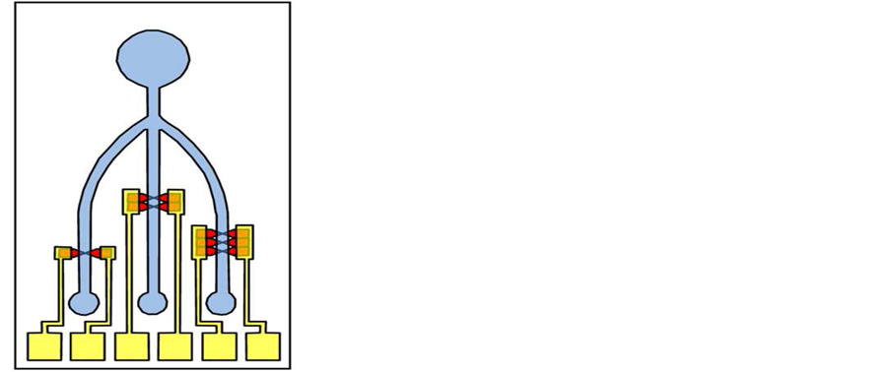

**Figure 2**. A lab-on-a-chip microfluidic device showing the inlet and outlets. (Source: Sharma et al., 2013.

Composition: MEMS come as capsules containing a light emitting diode, complementary metal oxide semi-conductor (CMOS) video camera, battery, and a transmitter.

Capability: with the aid of the capsular camera, image of the gastrointestinal lumen is taken and presented as moving pictures. A specific diagnosis of condition of the internal structures could be achieved with non-invasive methods. Gastric ulcers and tumors could be easily seen at their specific locations even at the stage of minute development.

Workings: A patient wears a belt which serves as a receiver for the transmission of images taken by the capsular camera that the patient must have swallowed. Movement of the capsule through the GIT is accompanied by pictures of the lumen taken by the ‘smart’ capsule and transmitted to the worn belt receiver. The images are projected on the screen to be seen by the expert. On seeing this, the medical Doctor can make inferences for possible diagnosis.

**2.1.3. Nano Biosensors**

These find a useful role in medical diagnosis because nanomaterials are chemically and biologically sensitive and have the ability to identify certain cells or some areas of the body.

Composition: these are made up of mainly a biological element (used for sampling), and physical element, (transducer for processing of sampling result).

Workings: Nanobiosensors, using indicators, are able to distinguish between cells and recognise certain cells especially cancer cells using perculiar biomolecules released or produced by such cells so that the rate of growth and development of such regions of the body is monitored as well as deliver specific medicines to such regions. Nanobiosensors could even work from outside the body, detecting large sized variations and signals are related to similar products within the body.

Capabilities: Using florescence properties of quantum dots of some metals such as Cadmium Selenide and Zinc sulphide, tumors within the body could be located by a medical practitioner by finding the fluoresced nanodot that was earlier injected. Cancerous tumors could be detected earlier by mere distinguishing between cells having a morphological or biochemical deviation from normalcy. Genetic defects could be recognized specifically and earlier due to its potential of detecting particular DNA. Literature has reported that researchers at Massachausset institute of technology (MIT) have discovered how to amplify weak biomarkers?peptides coated on nanoparticles which were released into the bloodstream by certain proteases that are often produced by cancer cells and then detected in urine .

**2.1.4. Nanoscale Single-Cell Identification**

This is an added application of nanotechnology. Employing nanolaser scanning confocal spectroscopy which has high single cell resolution, cancer cells having properties closely related to normal cells could be distinguished. Single cell protein could be detected using nanobiotechnology. Even little amounts of proteins in body fluids not identified by conventional methods could be identified by biobarcode assays.

**3. Future of Nanotechnology Application in Medical Diagnosis**

The constant giant strides recorded in the field of nanodiagnostics gives heightened hope for more possibilities. Such possibilities which are due to highly reduced-size particles, the high sensitivity of nanodiagnostics platforms, early detection of diseases and genetic dispositions at the molecular level using simple inexpensive rapid tests, and accurate imaging methods, have triggered the development of devices that can be used for accurate molecular diagnosis at point- of-care (POC). At present, available diagnostic technologies employ the principle of detecting biomarkers of various diseases. Hand held devices are in vogue, which are portable and easy to use, for instance Gluco-watch which can be used as a wrist watch has nano-chip biosensors that helps in monitoring of blood glucose. With such devices easily usable by some patients, hospital visits are reduced, physicians are eased, being under less pressure to concentrate with consequent improved practice. Medical practice is made easier with nanodiagnostics. Unlike now that Doctors have to order for medical tests to ascertain their educated guesses of a possible ailment, they can proactively prevent possible disease presentations employing the nanodiagnostic?based differentiation of diseases using DNA sequence analysis .

The avalanche techniques in Nanotechnology reveals how biological information can be acquired easily, quickly and inexpensively, then analyzed, thus enormously increasing the possibilities of achieving preventive medicine. With such move in medical diagnosis, therapy is becoming more specific and individualized with positive outcomes. In fact, therapy and diagnostics are increasingly fast becoming fused into a new specialist medical field designated theranostics; because the nanotechnology methods and medicines serve diagnostic and therapeutic purposes concomitantly. Examples are the contrast medium, made from nanoparticles, which brings with it directly the active substance in the event of a pathological tissue change and carrier systems which circulate preventively in the organism reacting to endogenous signals and automatically secrete active substances if needed. The production of nanomaterials that recognize cells and cell constituents, including individual genes, of impaired function and repair them of their own accord in the organism is also being researched.

Targeted transport of active substances can be used to introduce nucleic acids, DNA fragments, and individual genes into tissue and cells by means of nanoparticles. In a cutting-edge animal study using rats biodegradable, polymeric gene delivery nanoparticles have been shown to effectively kill glioma cells in the brain and extend the survival of the animals. This discovery makes it possible for further early diagnosis of medical conditions having genetic predispositions

The advances in the unending possibilities of nanotechnology in diagnostic approaches however raise ethical concerns. One such being, who should be in possession of the records of the total genetic sequence of an individual as analyzed by nanodiagnostics? Should a medical practitioner or institution have possession of all the genetic information about an individual? What about Issues of leakage of medical information as an angle to be considered? Also what of cases of unscrupulous individuals having access to such genetic information? The use of MEMS devices within the body is another area to be looked at. Should the capsule with the miniature nanotechnology embedded in it break down in the body, or what fate is the metal oxide with a high risk of free radicals released in the gastrointestinal tract?

**4. Conclusions**

There is more to nanotechnology and nanodiagnostics than mere discoveries in the laboratories and approvals by health institutions and authorities for use by consumers. Global coordination will be needed for establishing and maintaining international standards and nomenclature, toxicity testing, risk assessment and mitigation as well as public participation in achieving both benefits and safety, while reducing the gap between developing and developed countries is a necessity. This will enable internationally agreed concrete standardized characterization protocols for nanoscale items and products that can then be used with biological systems. Global coordination will also ensure monitoring for strict compliance with approved existing detailed well-established guidelines and specifications.

The future of nanotechnology and particularly nanodiagnostics is here! With proper attention to the associated ethical concerns and a global direction in establishment of international standards, the possibilities in this sphere of healthcare delivery will continue being in leaps and bounds.